**ECE-3502 IoT Domain Analyst LAB(L9+L10)**

**Name: Alpanshu Kataria**

**Reg. No.: 18BCE1267**

**Faculty: Dr. Maheshwari R**

Lab 10

**Task:**

Health Care Machine Learning Supervised Learning in Knime Analytics Platform.

I’ll be using heart dataset from UCI:

<https://archive.ics.uci.edu/ml/machine-learning-databases/heart-disease/processed.cleveland.data>

**Flow:**

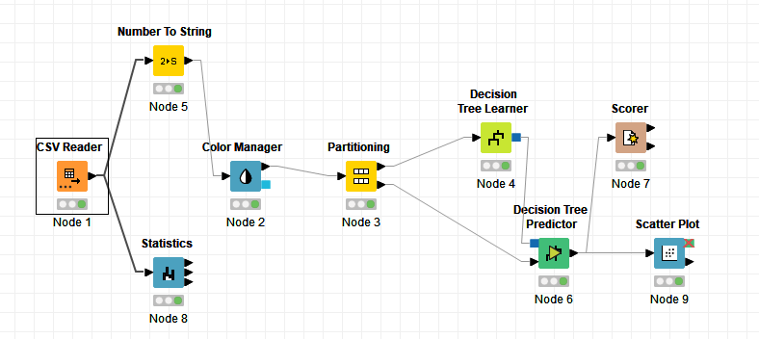

**CSV Reader:**

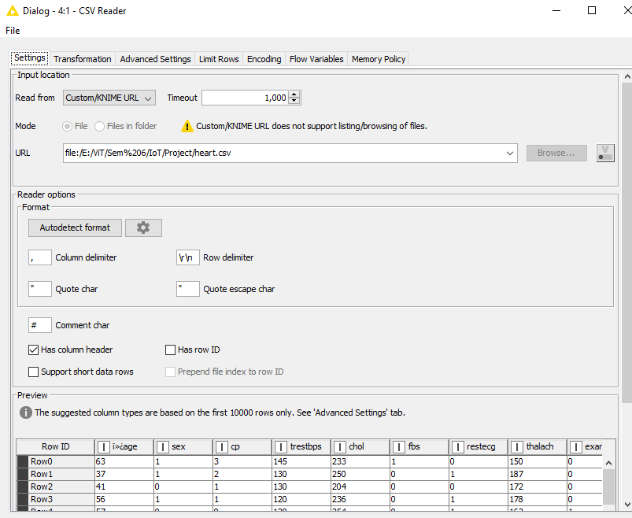

**Statistics Node:**

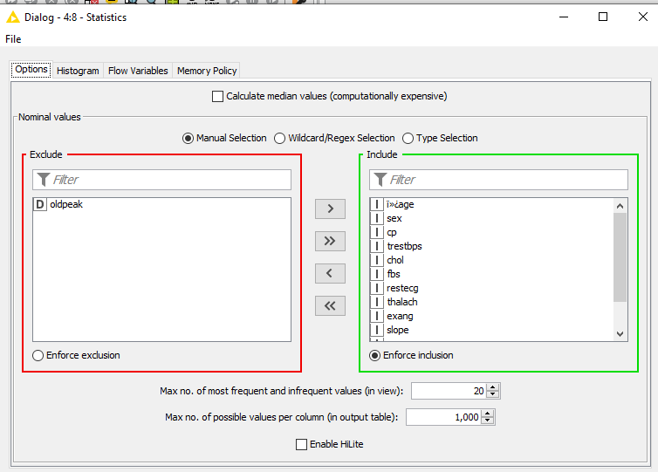

**Number To String Node:**

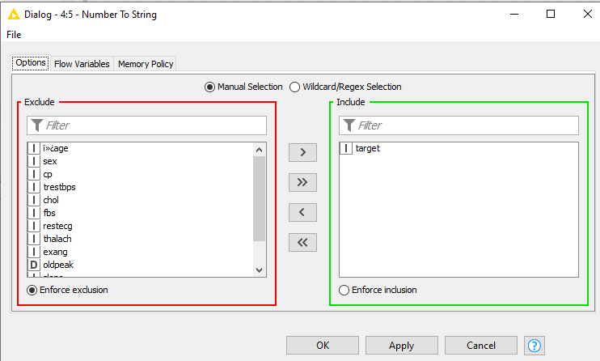

**Color Manager Node:**

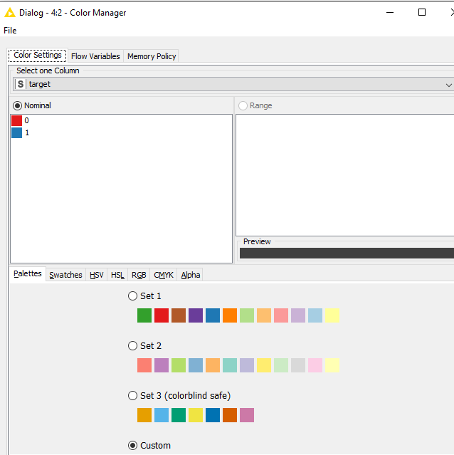

**Color Manager Node Output:**

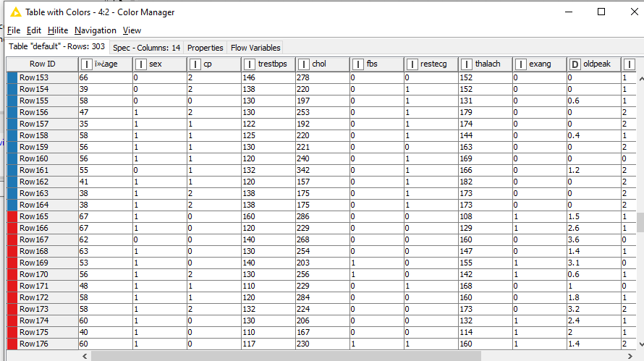

**Partitioning Node:**

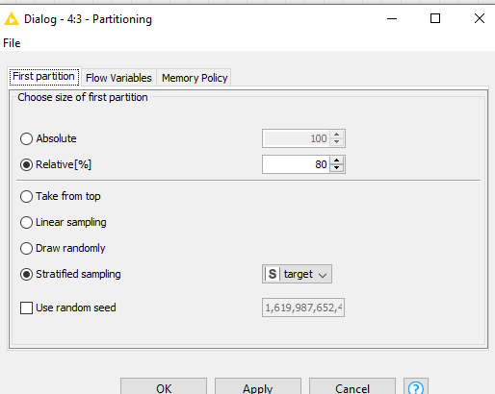

**Decision Tree Learner Node:**

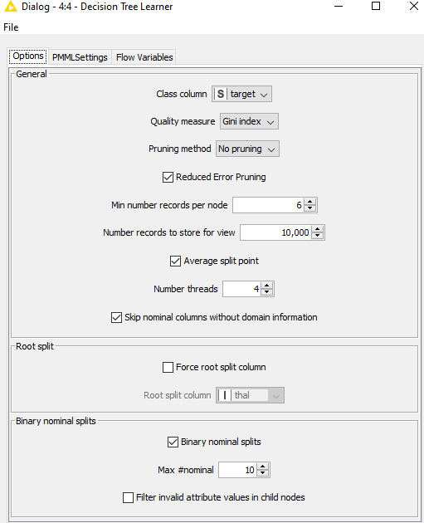

**Decision Tree Learner Node Output:**

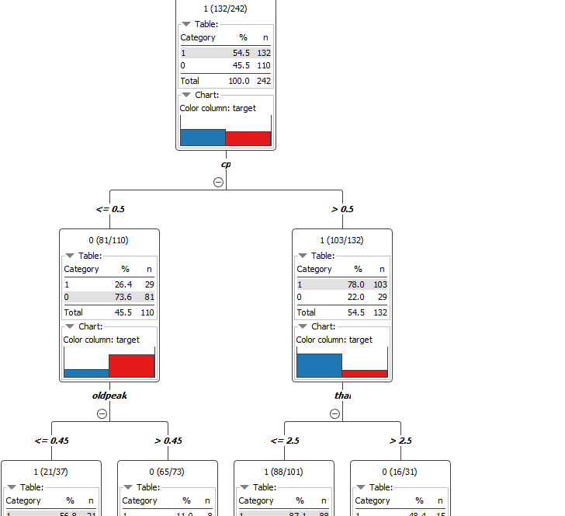

**Decision Tree Predictor Node:**

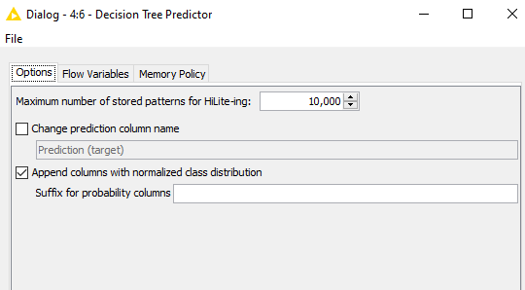

**Decision Tree Predictor Node Output:**

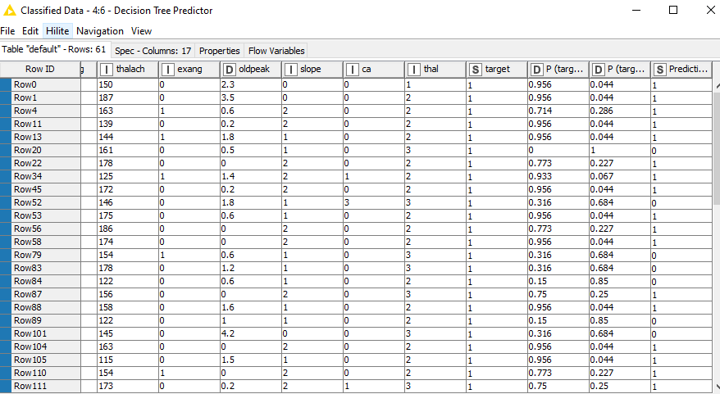

**Scorer Node:**

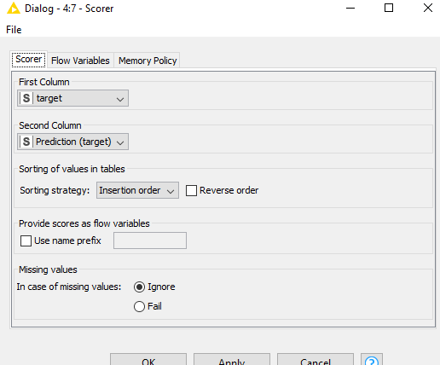

**Scorer Node Output:**

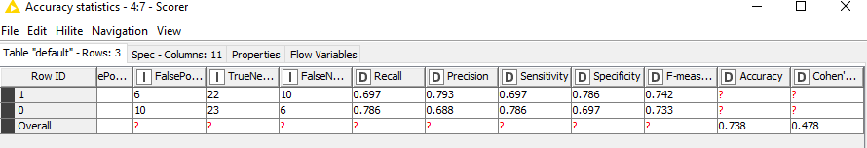

**Scatter Plot Node:**

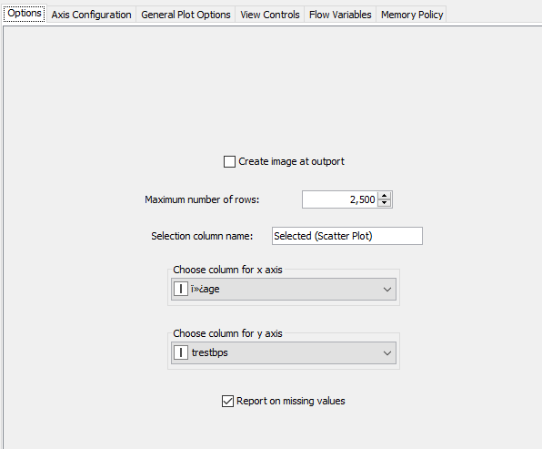

**Scatter Plot Output:**

